

Eproject

**Web Designing**

**EXCELLENT COACHING**

|  |  |
| --- | --- |
| **Authors** | **C1812G - Group Aptech C1812G** |
| 1. TIN NGUYEN DUC - Student1165112  (Leader) 2. KHANG LE NGUYEN- Student1163733 3. YEN DO HOANG- Student1166628 4. NAM NGUYEN VU NHAT - Student1185971 |
| **Centre Name** | Aprotrain Aptech |
| **Date** | 26th ,October 2019 |
| **Semester** | 1 |
| **Instructor** | NGUYEN TRUONG NGOC KHAC |

**HCM City, 19th November 2019**

**CATEGORY**

**WHAT IS THIS EPROJECT?**

**DATABASE DIAGRAM ……………………………….……………….……….** 2

**CHAPTER I: OVERVIEW …….………………………………………….….....** 3

* 1. Introduce the topic ....................................................................... 3
  2. Sitemap ……………………………………………………………….4
  3. Purpose of website ...................................................................... 4
  4. Some main pages ........................................................................ 4

**CHAPTER II: ANALYSIS EPROJECT**

1. Functional Requirement ................................................................ 5

**CHAPTER III: EPROJECT DESIGN**

1. Design Eproject by DFD

* Define DFD
* Analysis
* Design
* Communication
* Document
* The main Component of Context Diagram
* The process: shows the common function of system
* DFD Level 0: Context Diagram
* DFD Level 1.0: Customer
* DFD Level 1.1:
* DFD Level 1.2:
* DFD Level 1.3:
* DFD Level 2.0: Admin

1. Design FlowCharts

* Login
* Register
* Order
* Search
* Upload

**CHAPTER IV: INTERFACE SNAPSHOT**

* Home Page
* Course Detail Page
* Cart Page
* Payment Page
* Invoice information Page
* Login Page
* Registry Page

**CHAPTER V: USER GUIDE**

1. Home Page
2. Course Detail Page
3. Payment Page
4. Invoice information Page
5. Footer

**CHAPTER VI: ADMIN GUIDE**

1. SiteMap
2. Details of Pages
3. Login Page
4. Home Page
5. Category Manager
6. Courses Manager
7. Account Manager
8. Teacher Manager
9. Invoice Manager

**CHAPTER VII: VIEW DETAIL OF ALL COURSES**

**So what is this eProject?**

eProject is a step-by-step learning environment that closely simulates the classroom and Lab based learning environment into actual implementation. It is a project implementation at your fingertips!! An electronic, live juncture on the machine that allows you to

* Practice step by step i.e. laddered approach.
* Build a larger more robust application.
* Usage of certain utilities in applications designed by user.
* Single program to unified code leading to a complete application.
* Learn implementation of concepts in a phased manner.
* Enhance skills and add value.
* Work on real life projects.
* Give a real life scenario and help to create applications more complicated and useful.
* Mentoring through email support.

**Database diagram**

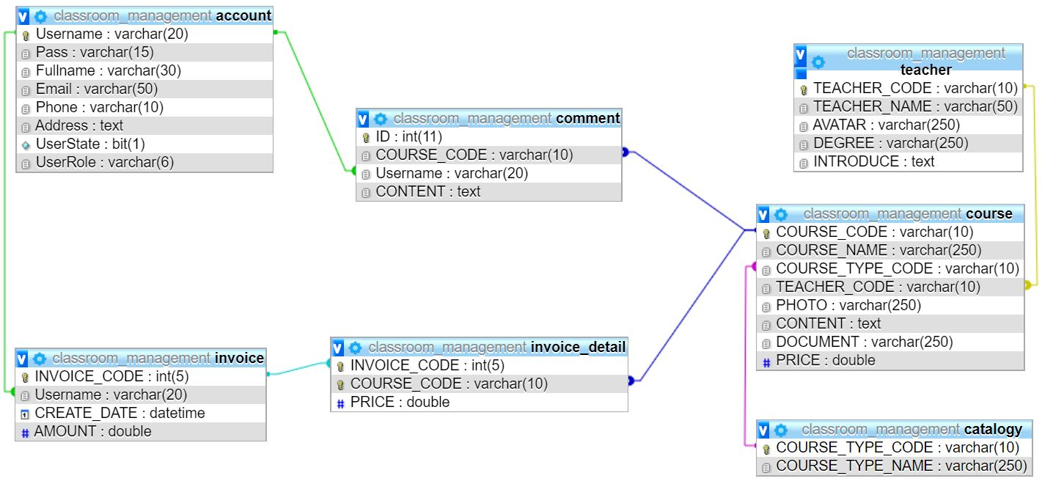

**CHAPTER I: OVERVIEW**

1. ***Introduce the topic:***

The thirst for learning, upgrading technical skills and applying the concepts in real life environment at a fast pace is what the industry demands from IT professionals today. However busy work schedules, far-flung locations, unavailability of convenient time-slots pose as major barriers when it comes to applying the concepts into realism. And hence the need to look out for alternative means of implementation in the form of laddered approach.

The above truly pose as constraints especially for our students too! With their busy schedules, it is indeed difficult for our students to keep up with the genuine and constant need for integrated application which can be seen live especially so in the field of IT education where technology can change on the spur of a moment. *Well, technology does come to our rescue at such times!!*

Keeping the above in mind and in tune with our constant endeavour to use Technology in our training model, we at Aptech have thought of revolutionizing the way our students learn and implement the concepts using tools themselves by providing a *live and synchronous eProject learning environment!*

1. ***Sitemap:***

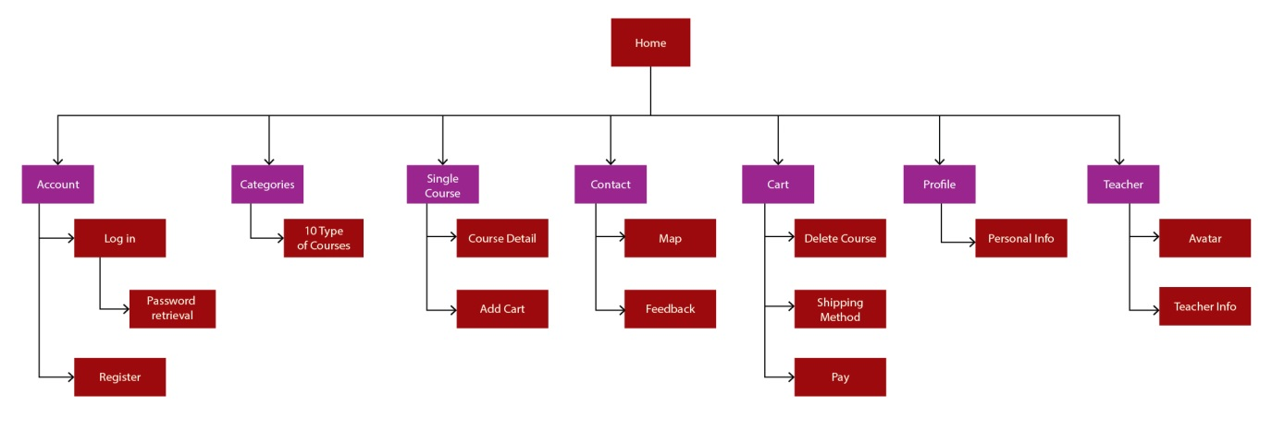

***3.* *Purpose of website:***

To meet the needs of education, training, an online training model (E-Learning) was born, meeting the integration trend of education and training. Based on the overview of the current E-Learning system, the article highlights the important role of this training model in the social learning movement.

***4. Some main pages:***

* **Home page**: This is a site that introduce store specific courses. In addition, you can learn more about other types of courses, link to website like Facebook, youtube, zalo to watch video clips or ask questions.
* **Course Detail page**: This is a detail page for the course content
* **Cart page**: This is the courses view page purchased.
* **Payment page**: This is the infomation entry page to pay for your order.
* **Invoice infomation page**: This page displays the distance of customers coming to the shop. This page contains shop information for customers to contact

**CHAPTER II: ANALYSIS EPROJECT**

Excellent Coaching is into business for more than a decade. They have been advertising about their coaching classes through newspapers, pamphlets, television. Now with changing times, they have decided to go online as most of the students today are frequent users of Internet. They have planned for a website with complete details about the Coaching classes.

You are supposed to create a website for them with the below mentioned requirement specifications.

The website is to be developed for the Windows Platform using HTML5, JavaScript and Geolocation. The site should work well in all leading browsers including Chrome, IE, Firefox etc.

1. ***Functional Requirement:***

The Web site is to be created based on the following requirements.

1. The Home Page should have suitable logo, and decent colour combination.
2. Information should be neatly placed at suitable location.
3. Various pages having information about different courses/subjects taught at the classes, Faculty/Teachers complete information and previous year’s success stories should be listed.
4. The site should display a menu which will contain the options for brief introduction about the above mentioned information, location/address of the coaching classes and any other information if required.
5. The information should be categorized according to different subjects like if a User wants to see details of ‘Commerce’ then he click on a Link/button/menu etc and he will see details of course structure of commerce. Similarly for ‘Mathematic’, ‘Languages’ and other subjects.
6. When a user selects any course stream, complete list of subjects for that course stream will be displayed.
7. Details of the courses should be displayed on the Web Page along with the title and it should be stored in Individual Word documents which can be downloaded or viewed by the User who wishes to see the same.
8. Price List for all courses should be available for download.
9. There should be a “Contact Us” page which will have the Address of the Coaching Classes and the mail address which when clicked will invoke the local mail client from where they can send an email. Address of the Company should be displayed using GeoLocation API (eg. GoogleMaps).

**CHAPTER III: EPROJECT DESIGN**

1. ***Design Eproject by DFD:***

* **Define DFD**

Data Flows Diagram (DFD) describes the information flow in the system. The next step of system analysis is to consider in detail the information necessary for the implementation for functions discussed above and the one necessary for the improvement of the functions. Modeling tool frequently used for this purpose is DFD. DFD will support 4 main activities.

* **Analysis**

DFD is used to determine requirement of users.

* **Design**

DFD is used to map out plan and illustrate solution to analysis and users while designing a new system.

* **Communication**

One of the strength of DFD is its simplicity and ease to understand to analysts and users.

* **Document**

DFD is used to provide special description of requirement and system design. DFD provide an overview of key functional components of the system but it does not provide any detail on these components. We have to use other tools like database dictionary, process specification to get and idea of which information will be exchanged and how.

* **The main Component of Context Diagram:**

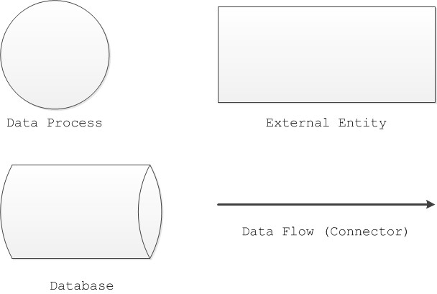

* **The process: Shows the common function of system**

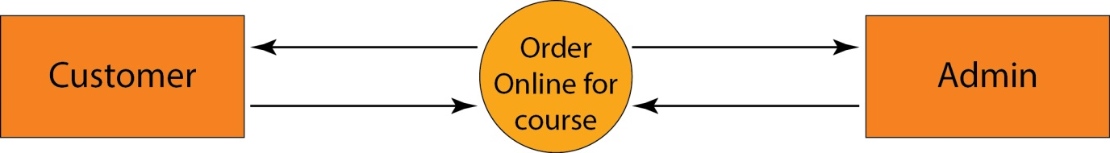

Level 0 – Context Diagram

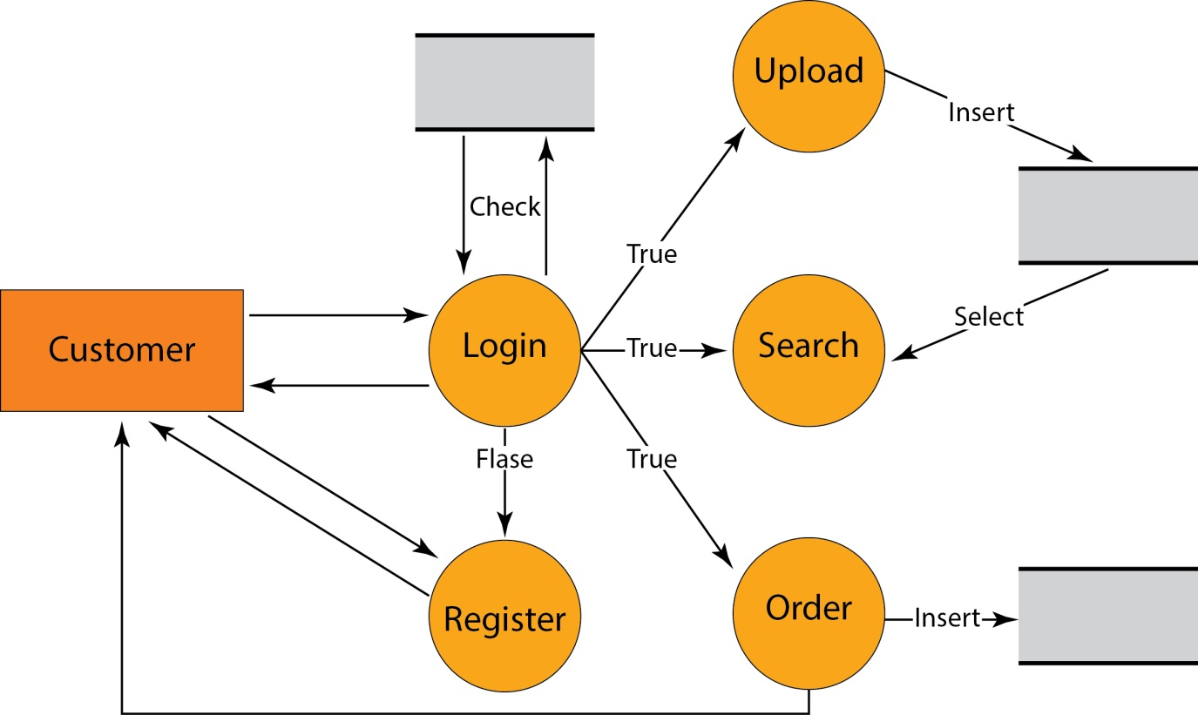

Level 1.0 - Customer

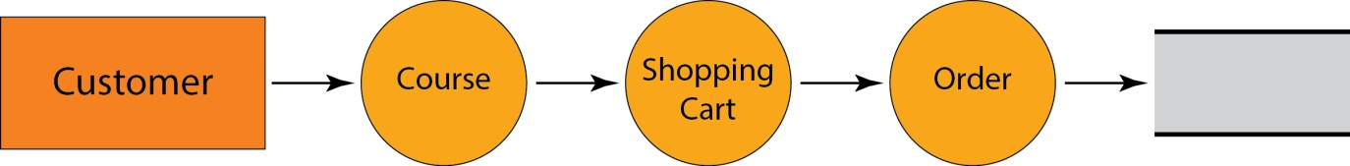

Level 1.1

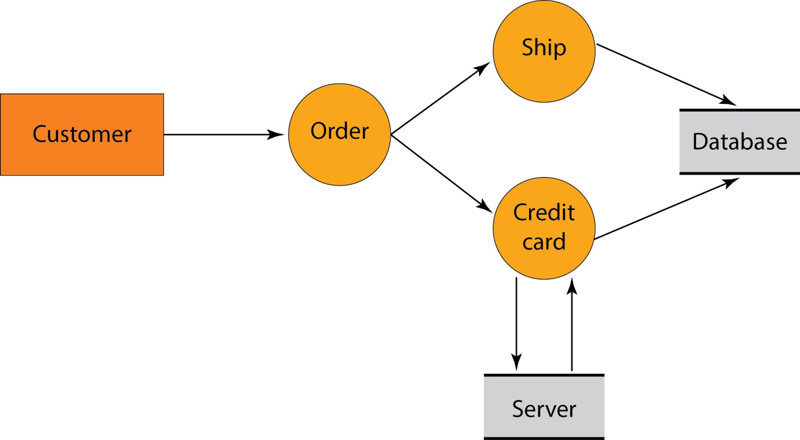

Level 1.2

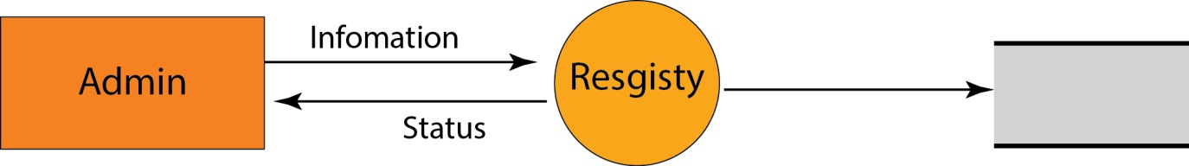

Level 1.3

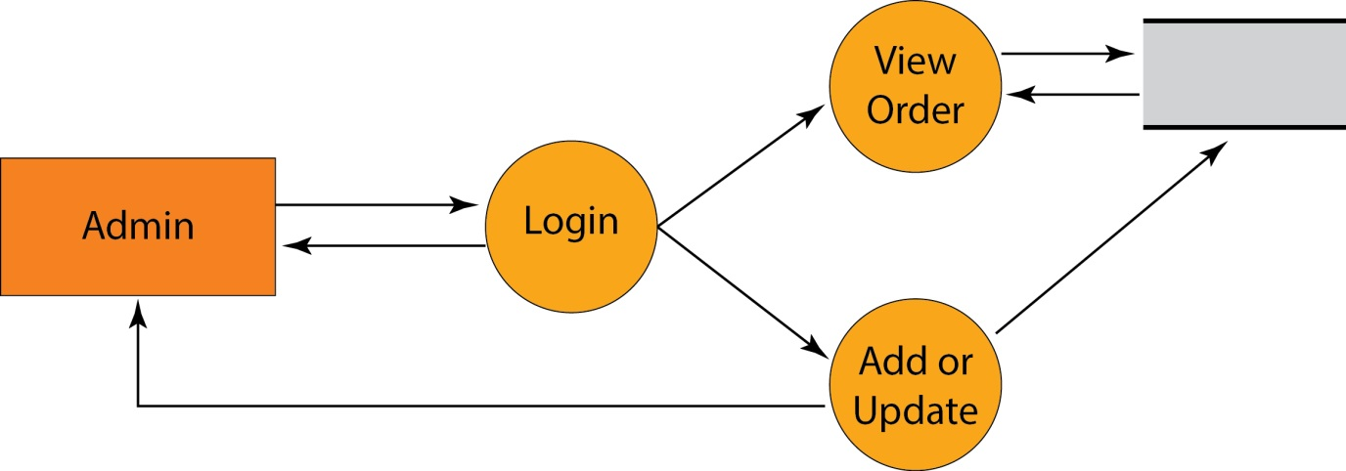Level 2.0 - Admin

1. ***Design FlowChart:***

* ***Login:***

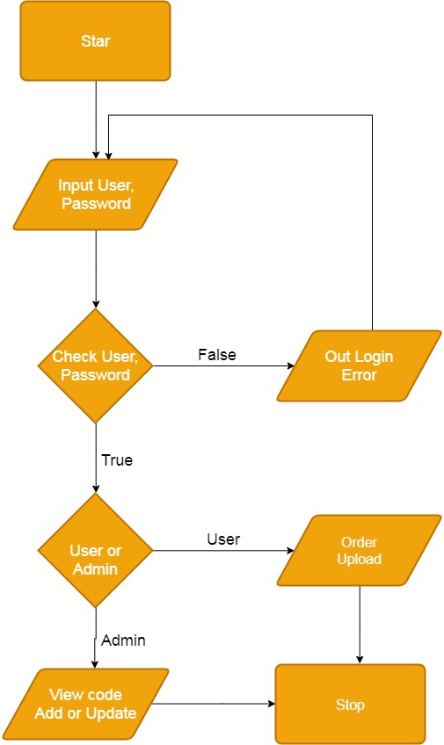

* **Register:**

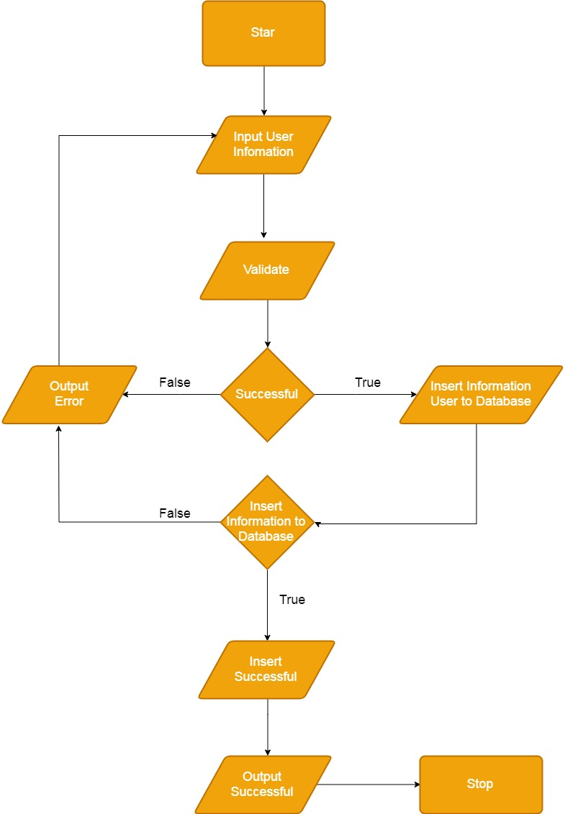

* **Order:**

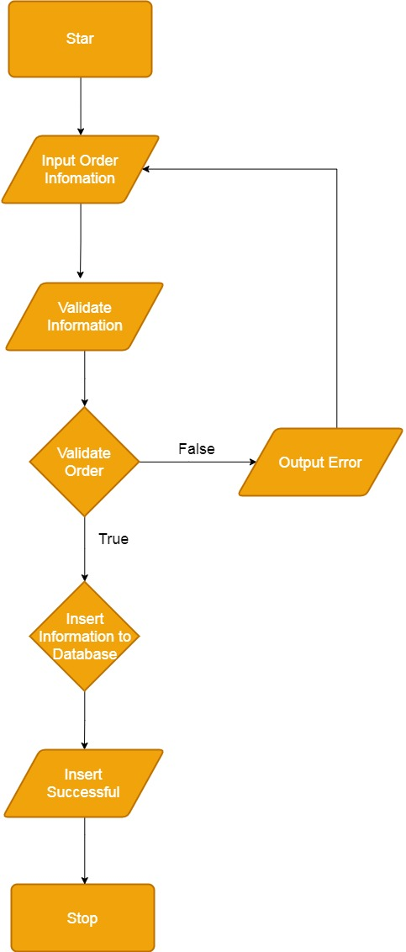

* **Search:**

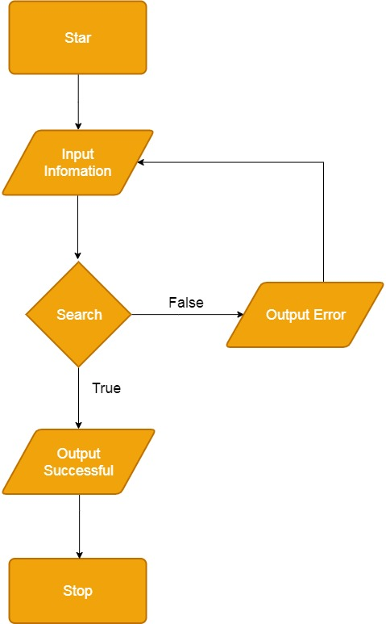

* **Upload:**

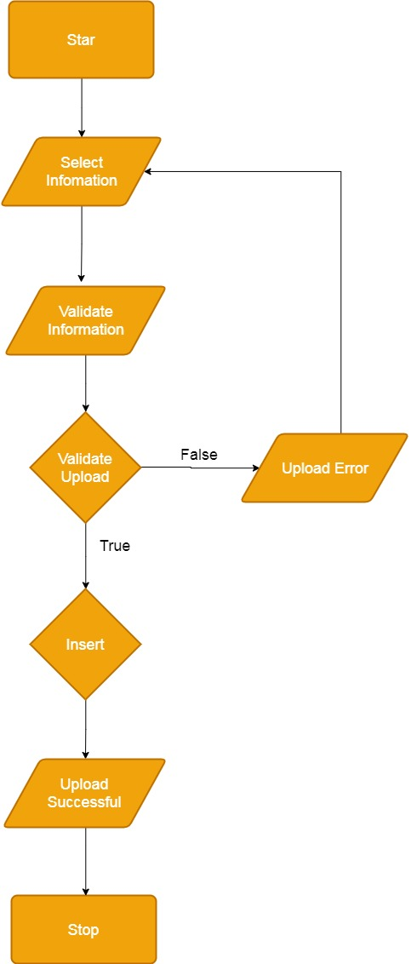

**CHAPTER IV: INTERFACE SNAPSHOT**

* **Home Page:**



* **Course Detail Page:**

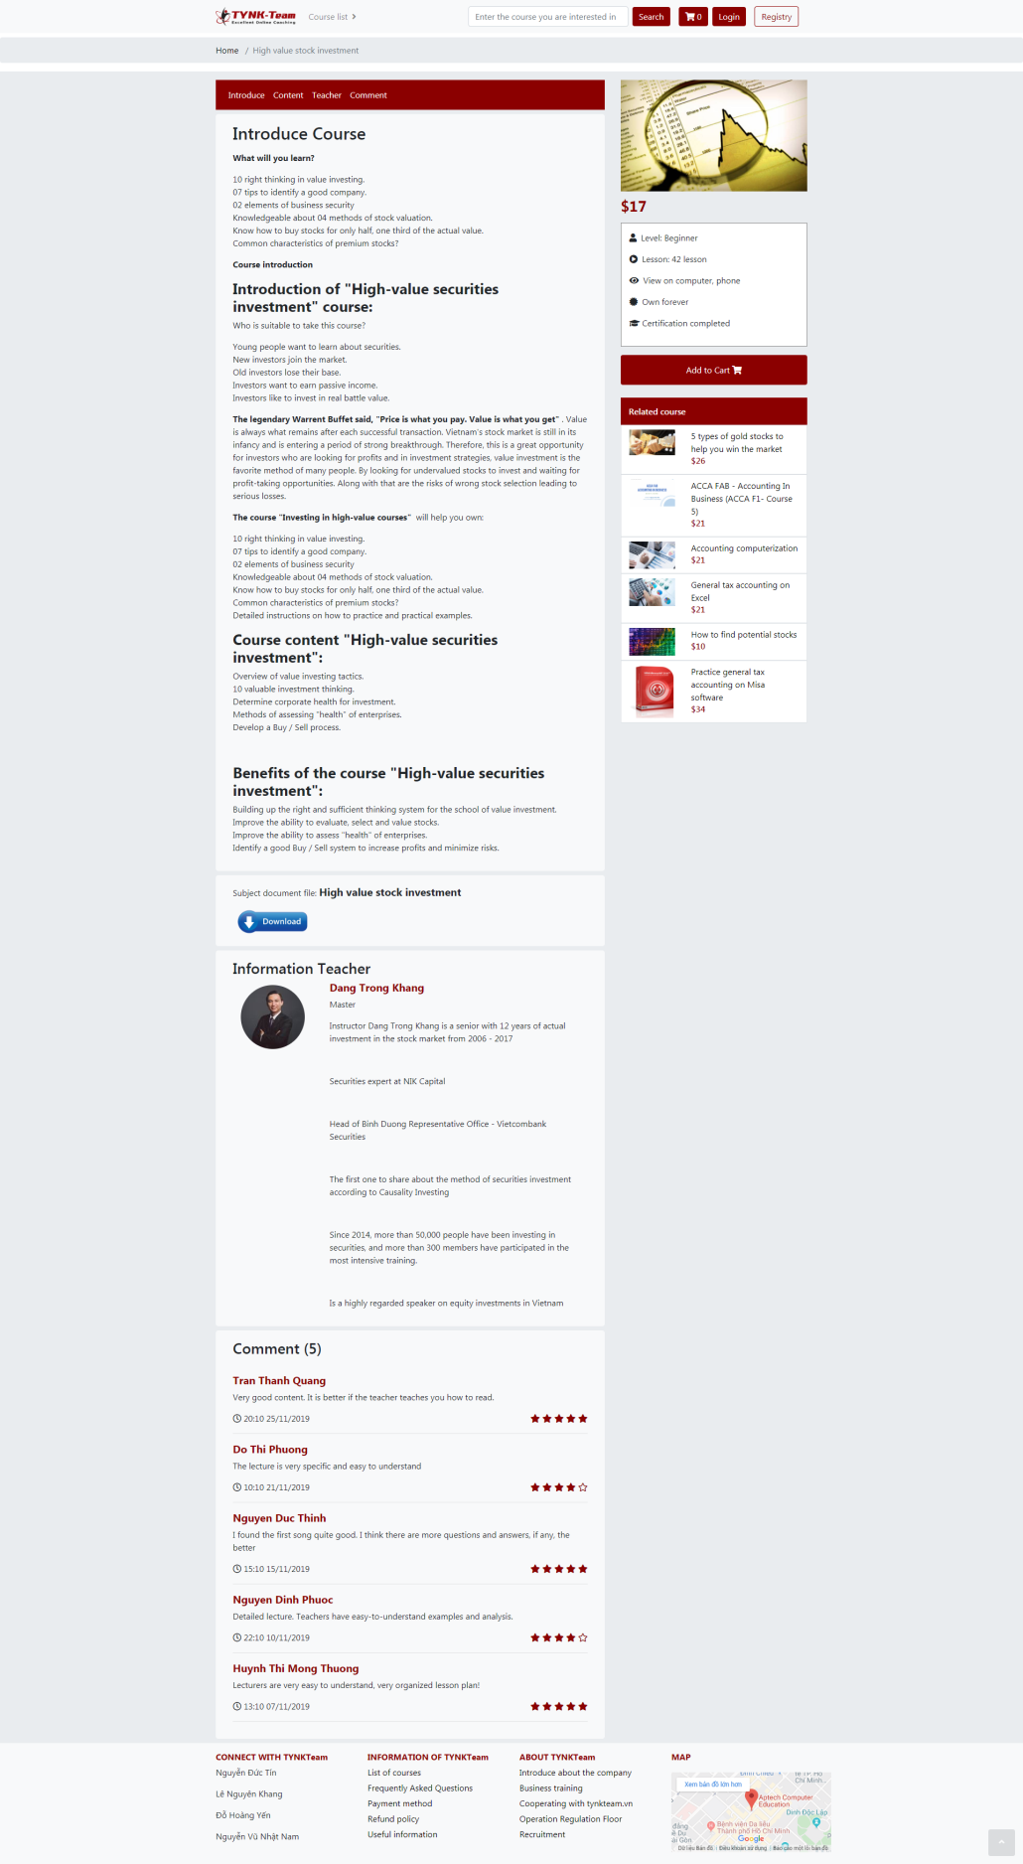

* **Cart Page:**

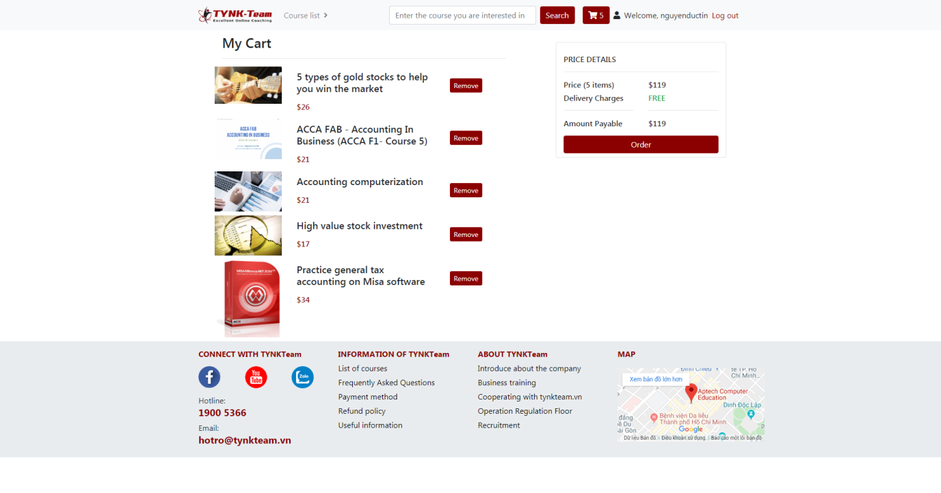

* **Payment Page:**

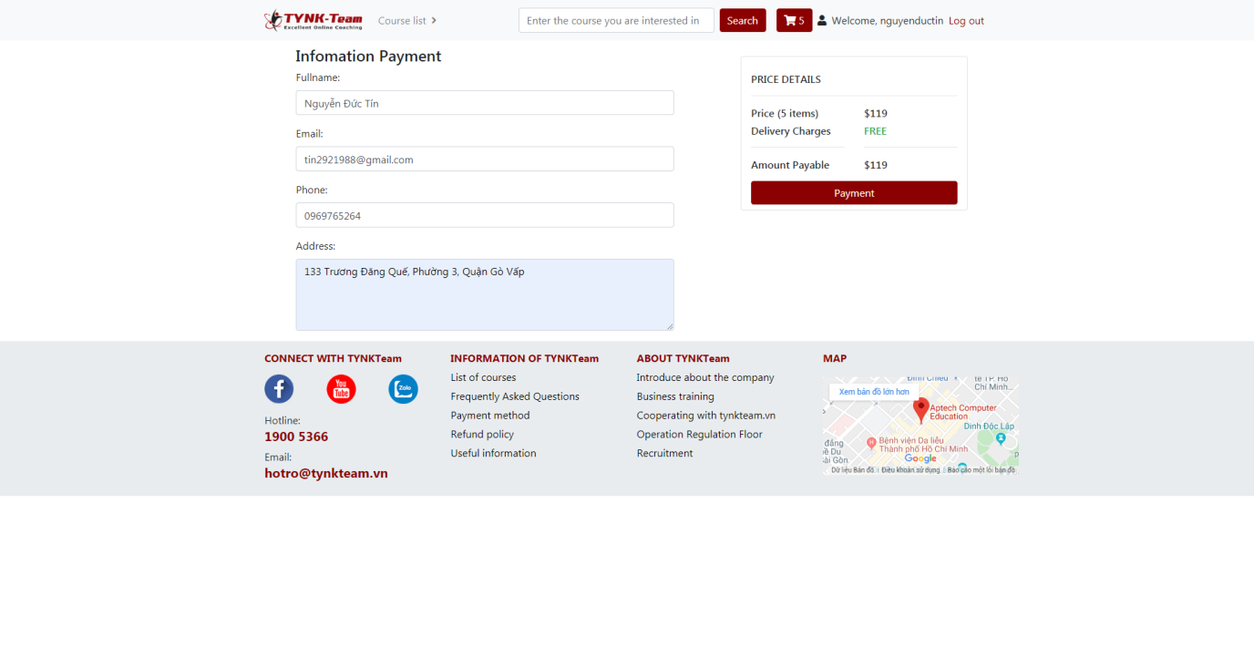

* **Invoice infomation Page:**

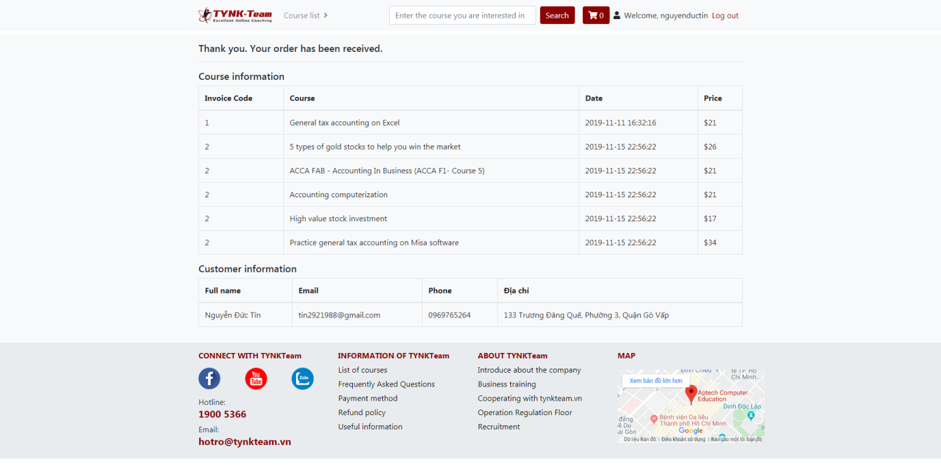

* **Login Page:**

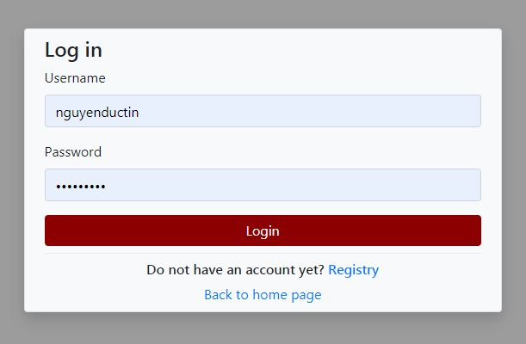

* **Registry Page:**

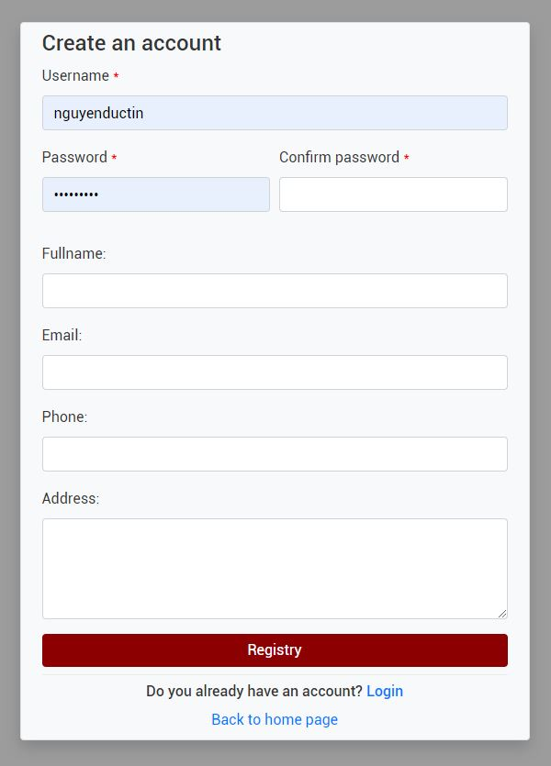

**CHAPTER V: USER GUIDE**

1. **Home page:**

* **The Welcome Page:**



* **The Login Page:**

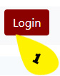

Customers can login to their account when clicking here:

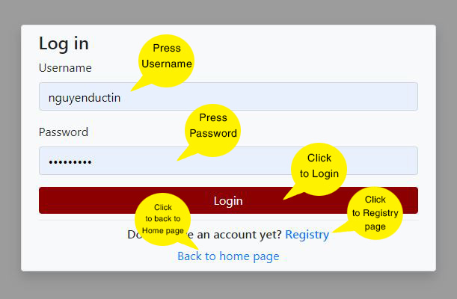

* 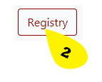**The Registry Page:**

Customers can register a new account here:

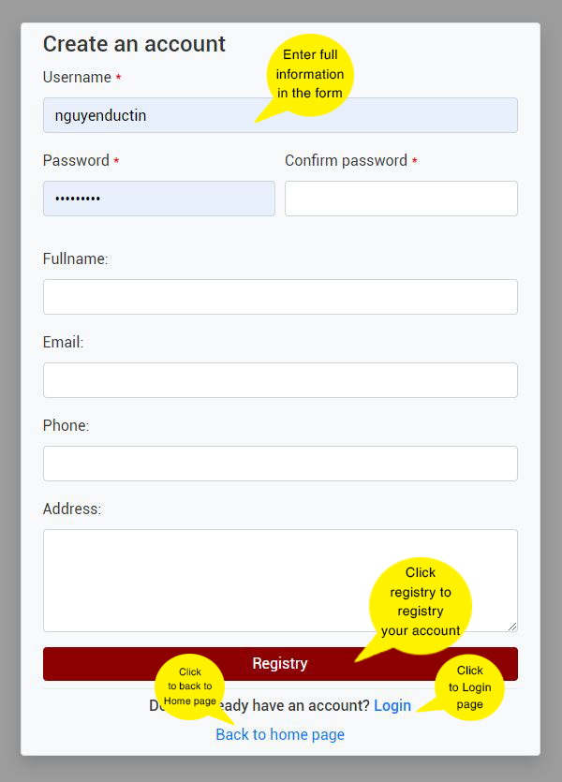

* **The Cart Page:**

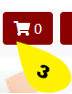

The Courses are selected by customers

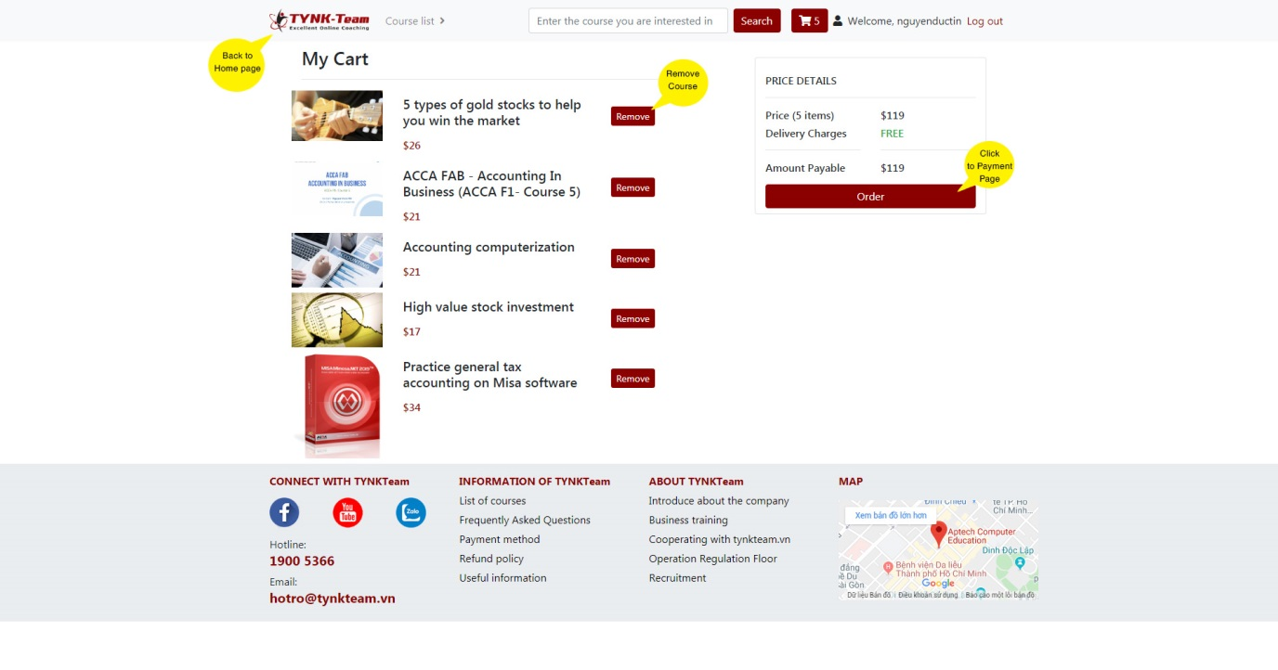

And:

Customers can search for products by entering here:

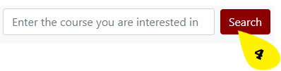

And customers can click on “Course list” to choose different types of courses:

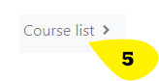

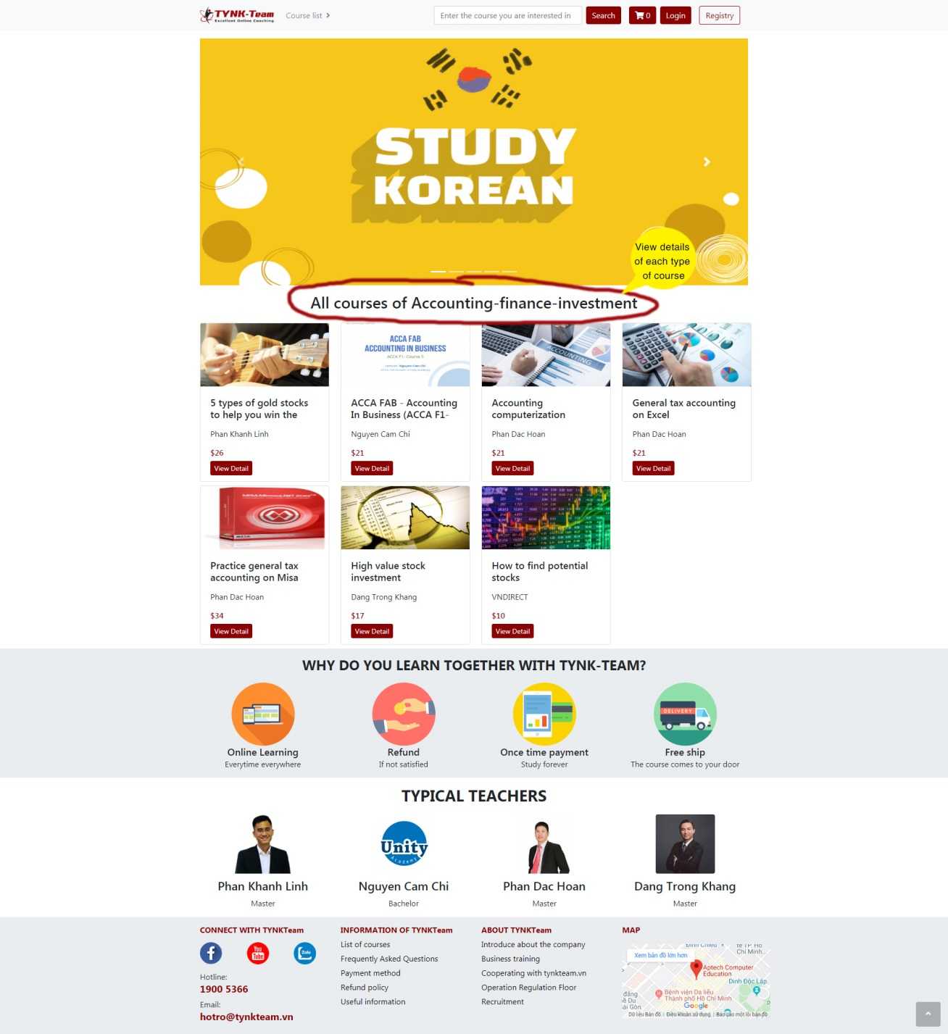

**B. Course Detail Page:**

Customers can click on “View Detail” to course detail page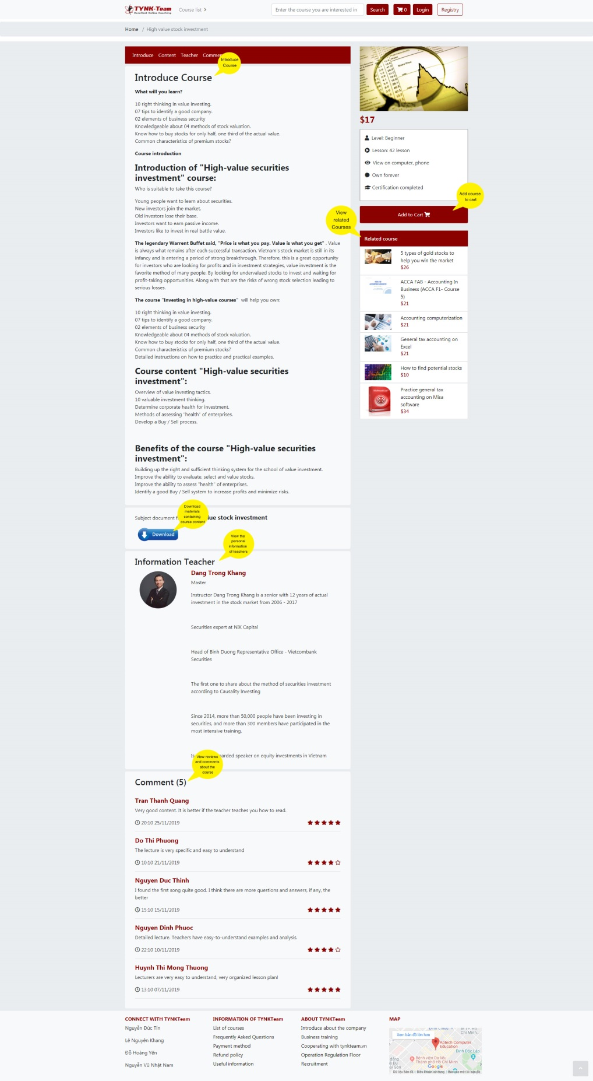

**C. Payment Page:**

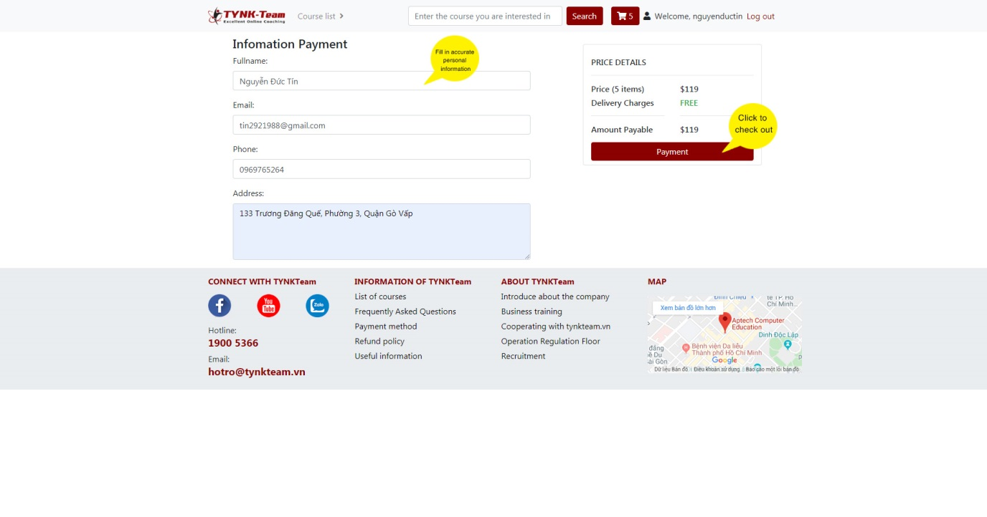

**D. Invoice information Page:**

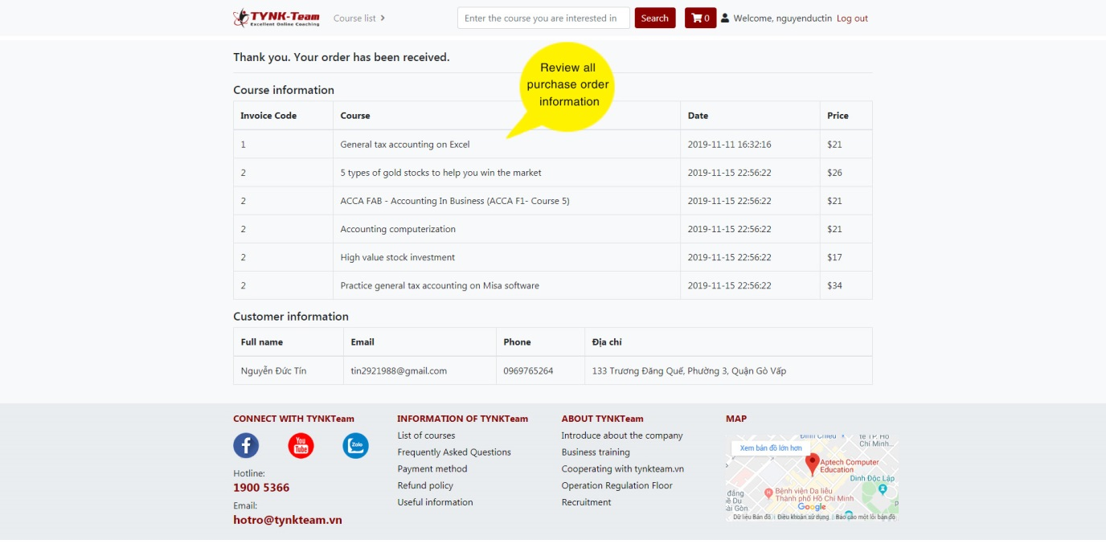

**E. Footer:**

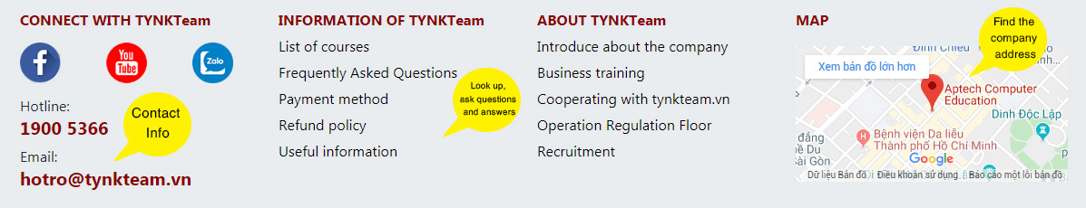

**CHAPTER VI: ADMIN GUIDE**

1. **Sitemap:**

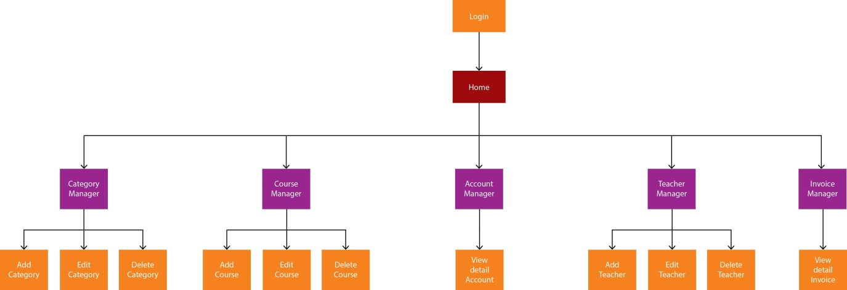

1. **Details of Pages**
2. **Page Login**

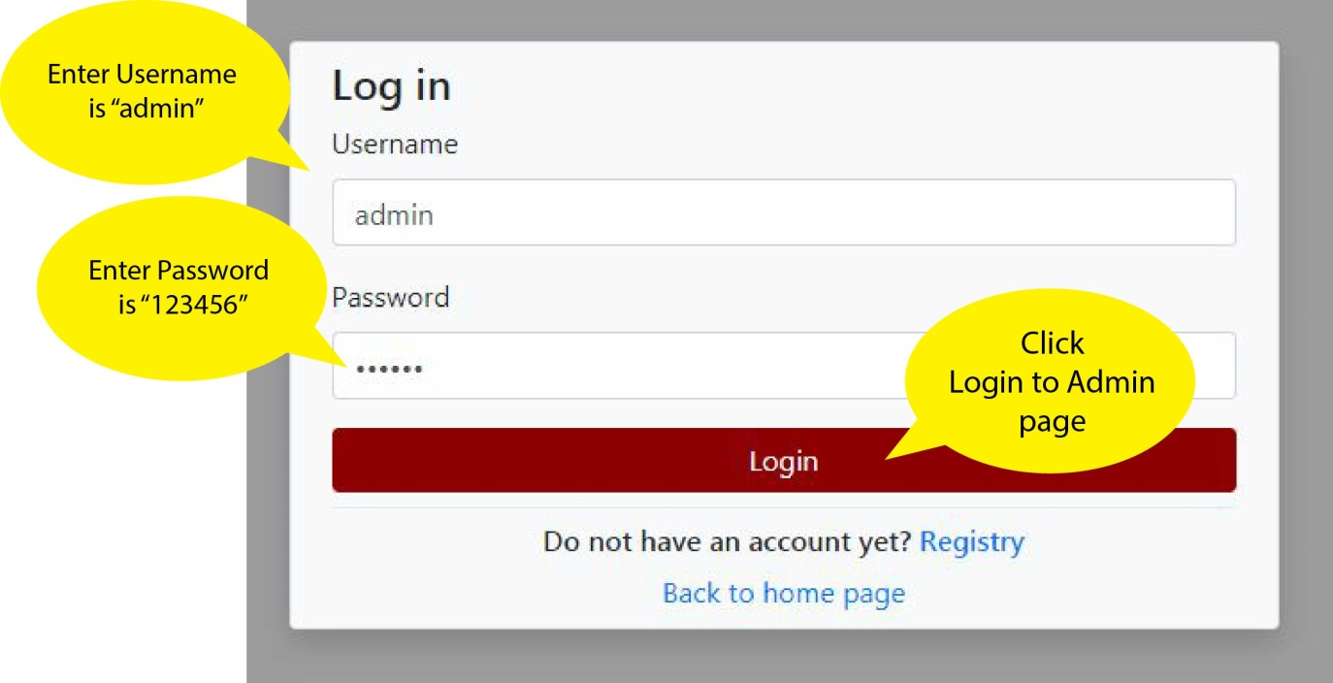

First, you will have to login with an admin account to be able to access the admin homepage.

1. **Page Home**

After you have successfully logged in, you will be redirected to the admin homepage. The following is a detailed description of the structure and function of each element on the page.

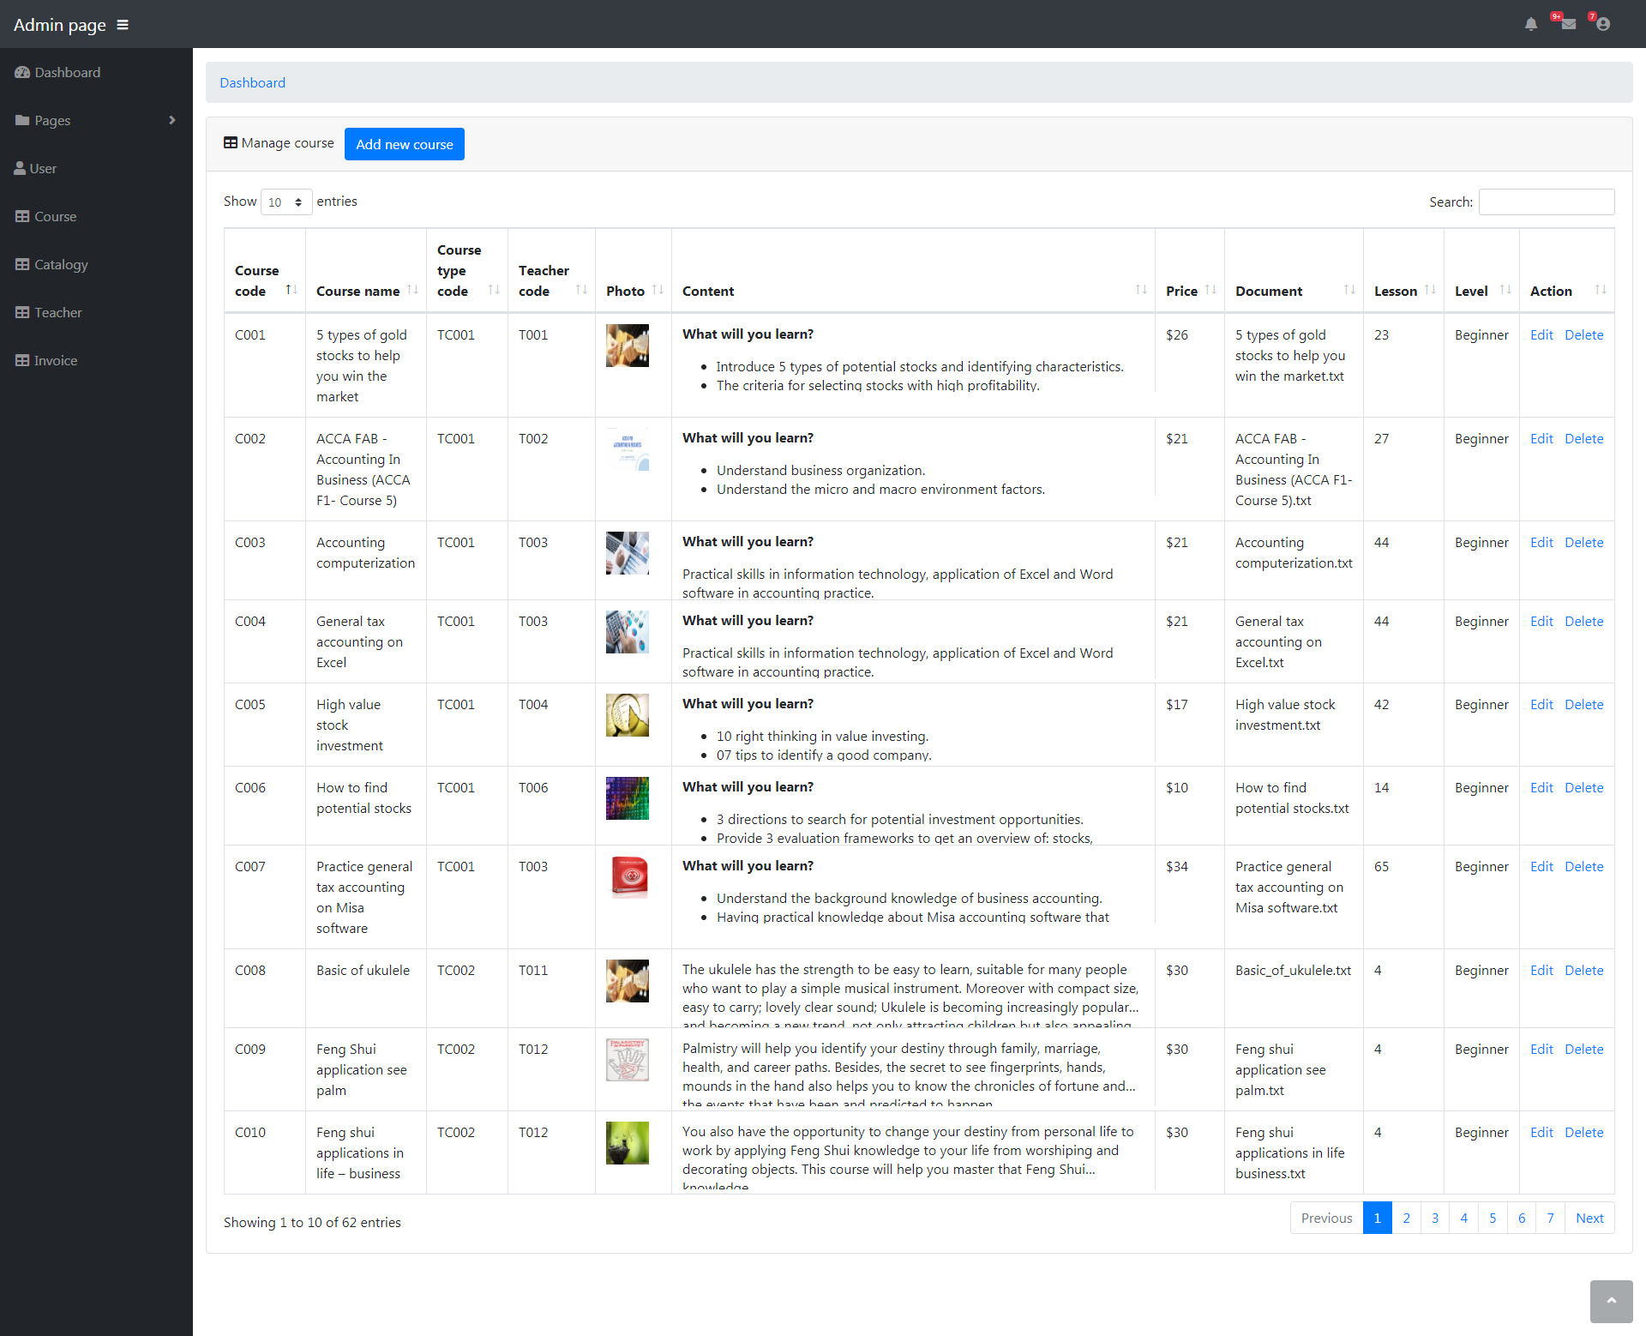 Here, you can see a number of statistics tables such as: total sales for a month, the total number of courses sold, total invoices, etc. In addition, there are TOP rankings that customers buy the most, TOP courses are sold the most.

1. Category Manager

This is workspace : You can see name Category and edit,delete Category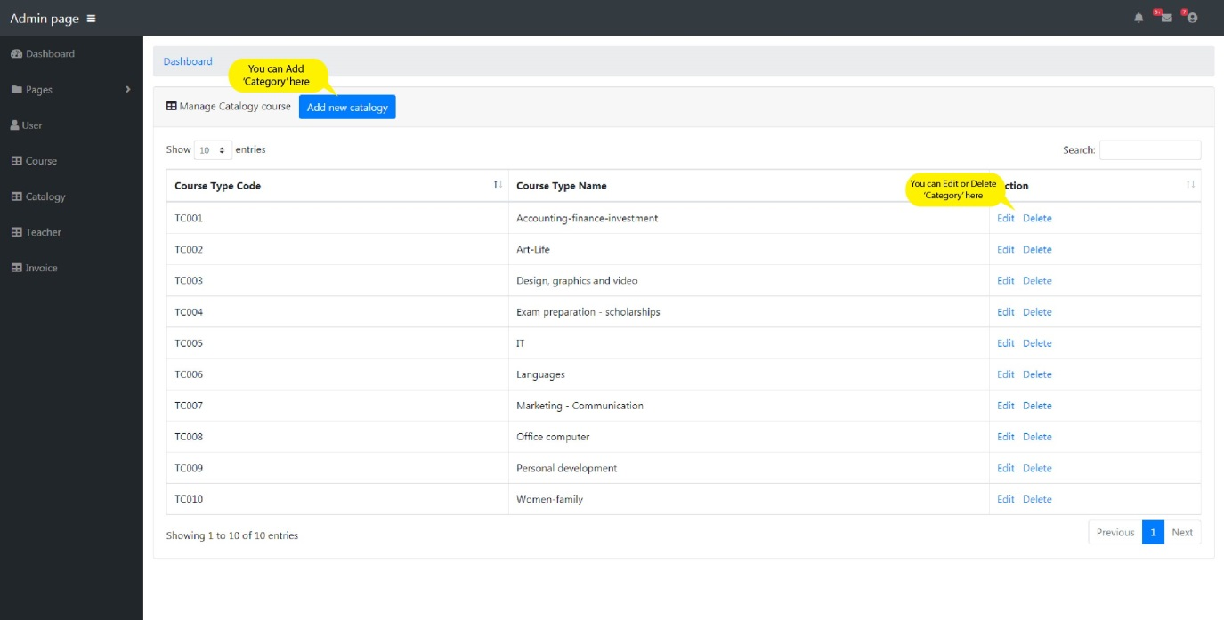

* This is where add Category:

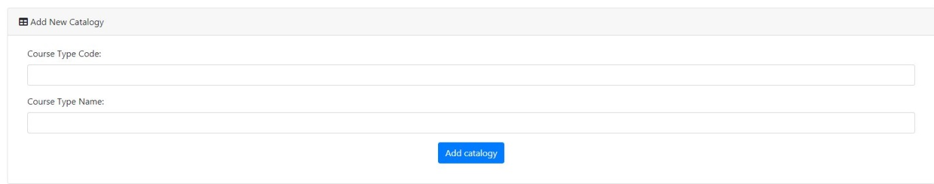

1. Courses Manager

* This is workspace: Let’s show list information of course

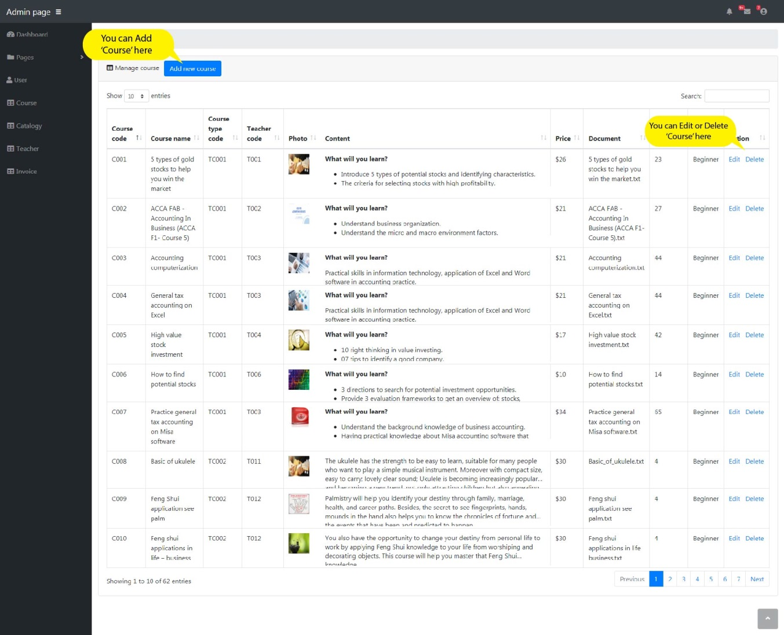

* This is where add courses:

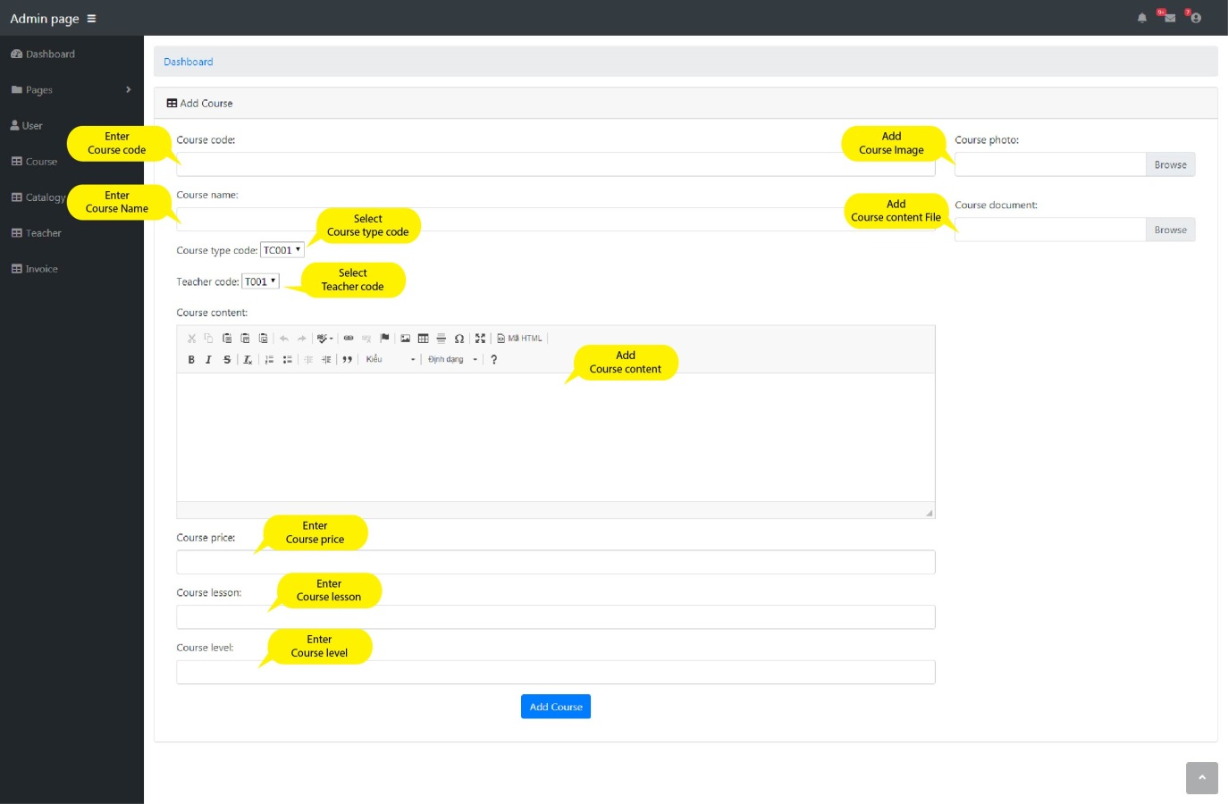

1. Account Manager: Let’s show information basic of customer.

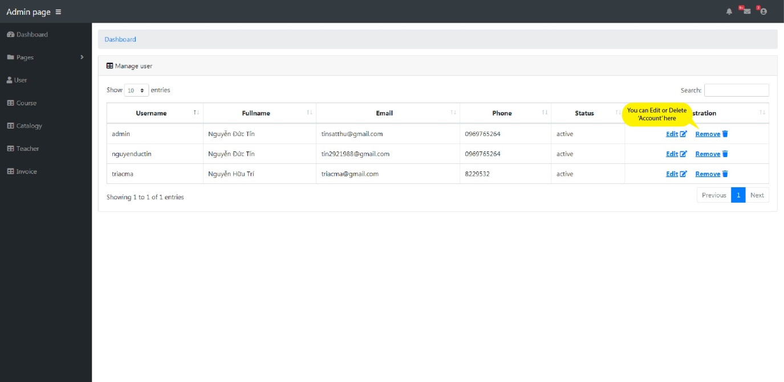

1. Teacher Manager: Let’s show name, avatar and information of teacher.

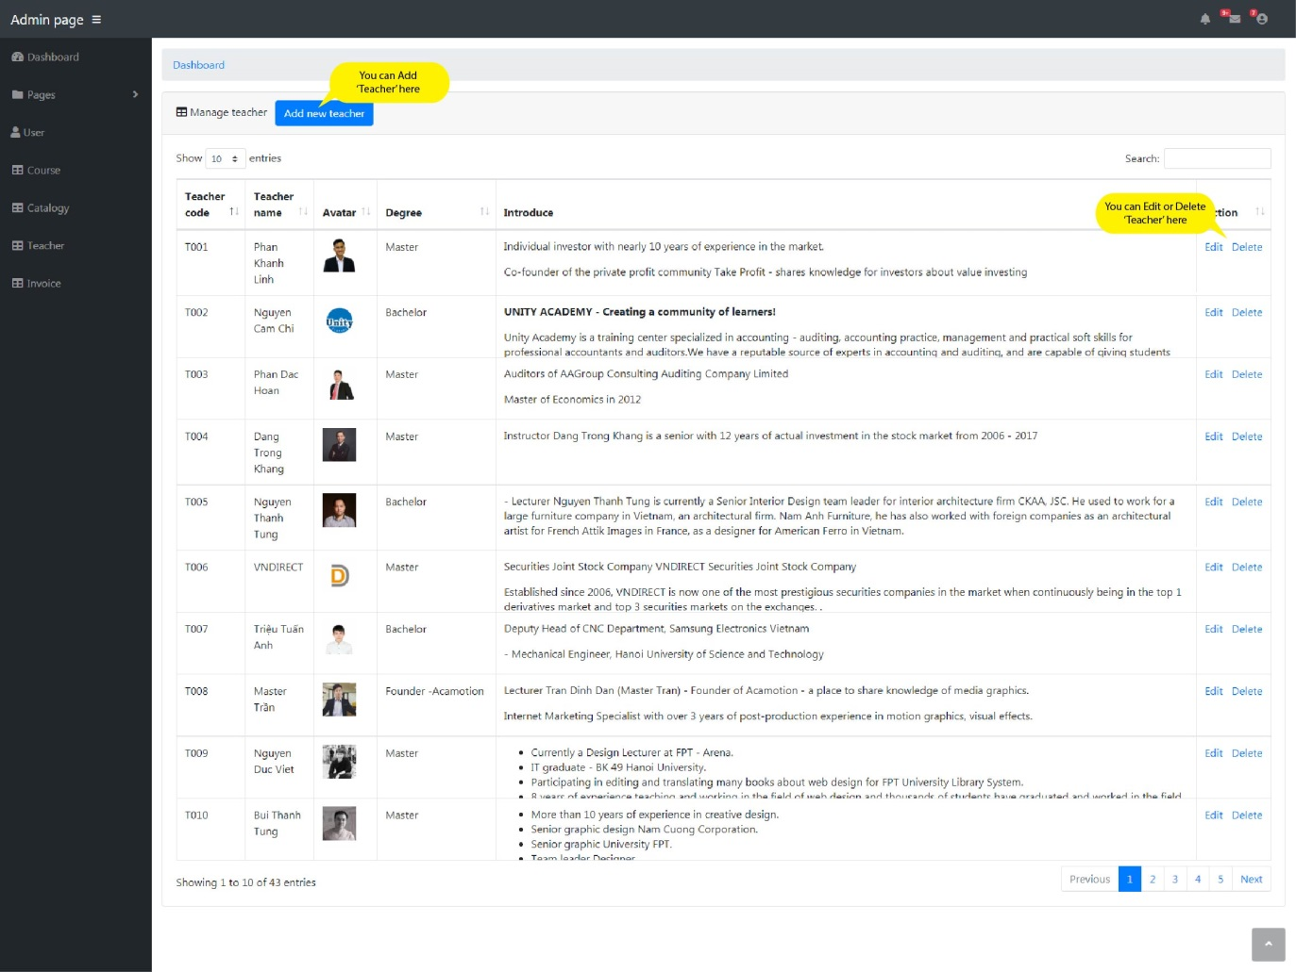

* Add Teacher here:

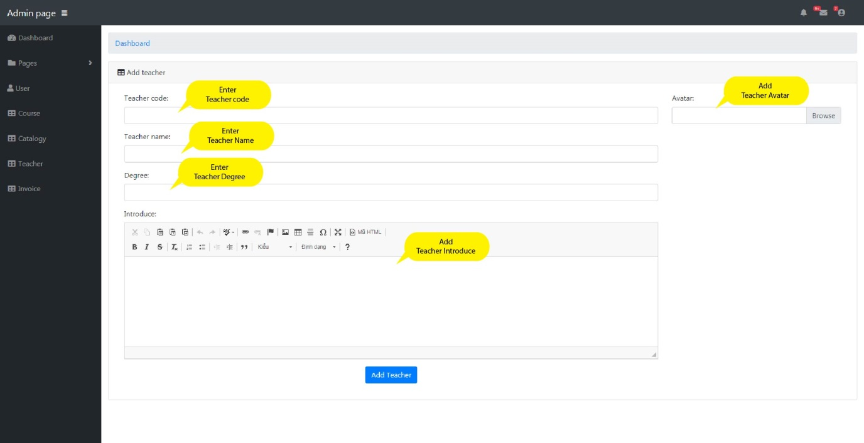

1. Invoice : You will see id invoice, day create, price money and course purchased.

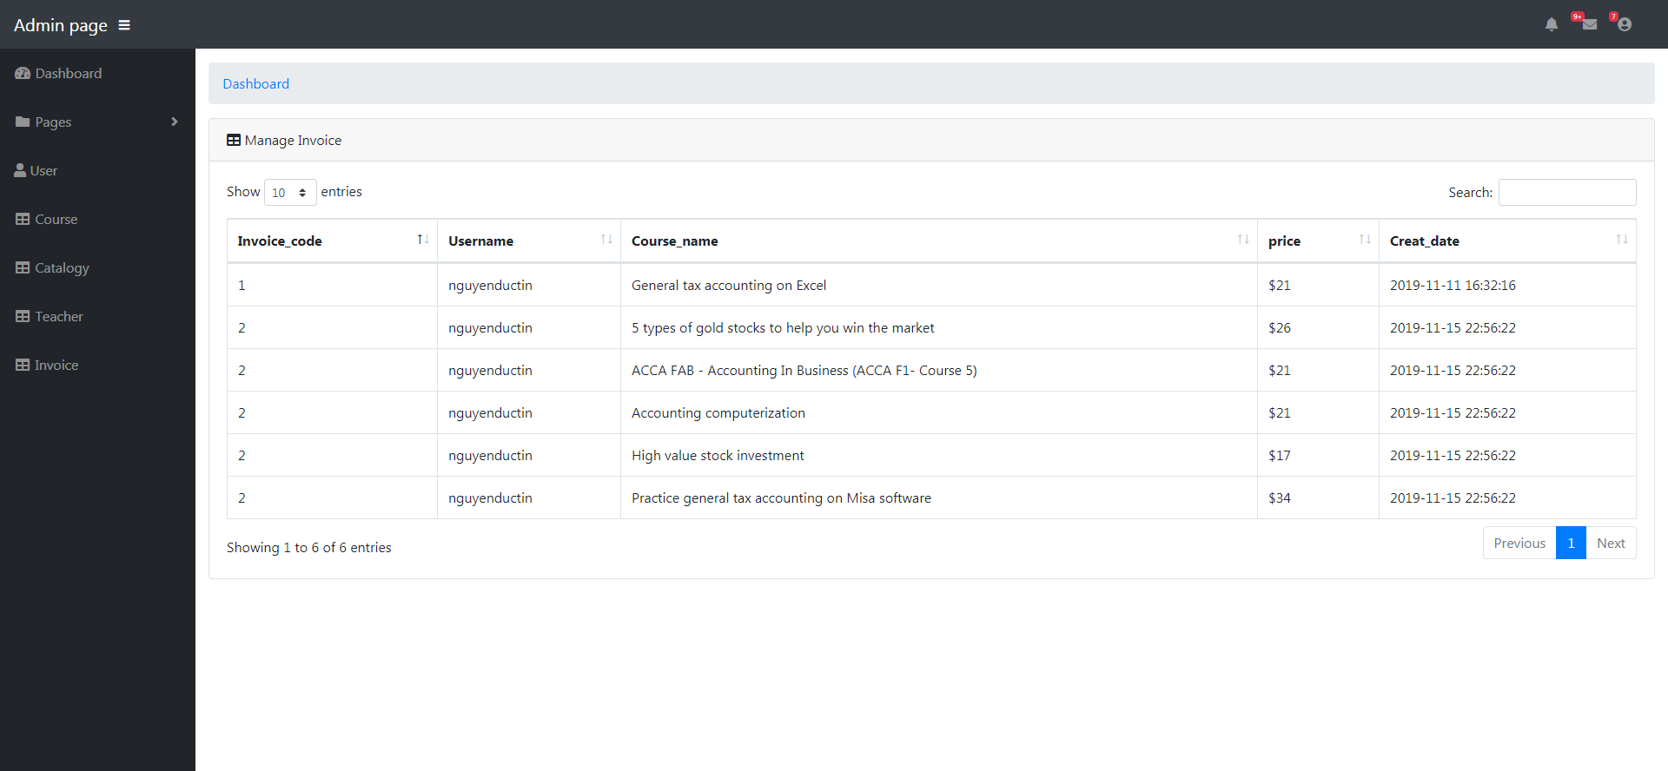

**CHAPTER VII: VIEW DETAIL OF ALL COURSES**





